**Statistical Analysis Report**

**1. Describe the Data:**

The dataset in question depicts annual salaries within a European country. While the specific data isn't derived from real-world information, a sample dataset comprising 1000 entries was created for explanatory purposes. The data was generated using a normal distribution with an average (μ) annual salary of 50,000 Euros and a standard deviation (σ) of 10,000 Euros. Each entry in the dataset represents the yearly income of an individual within the context of this simulated scenario.

**2. Describe the Distribution:**

The sample data is portrayed graphically using a histogram, and a normal distribution curve is overlaid to represent the distribution pattern. The resultant graph displays a symmetrical and bell-shaped curve, a characteristic feature of a normal distribution. This shape indicates that the majority of salaries are concentrated around the mean value, suggesting a central tendency. Additionally, there are fewer occurrences of extremely high or low salaries, contributing to the balanced and typical distribution pattern observed in the graph.

***Distribution of Annual Salaries***

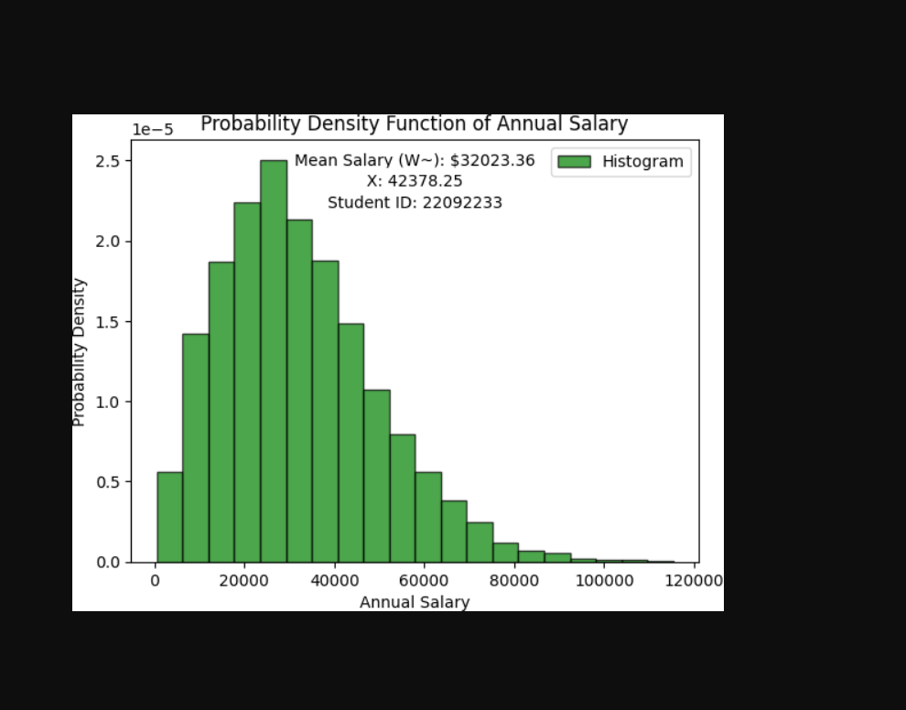

**3. Calculation of Mean Value:**

The mean annual salary is a measure of central tendency and is calculated using the formula:

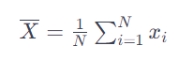

Here, (N) represents the total number of entries in the dataset, and represents each individual salary. For the provided sample data, the mean salary is approximately 49987.84 Euros. The mean is indicated on the graph by a blue dashed line.

4. Calculation of Required Value X:

The required value (X) is determined as the 75th percentile of the sample data, representing the salary below which 75% of the data falls. The calculation is expressed as:

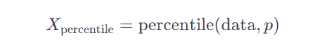

In this formula, is the dataset, and is the desired percentile (in this case, 75). For the generated sample data, the calculated value for X at the 75th percentile is approximately 58603.95 Euros. This value is depicted on the graph by a red dashed line.

**Conclusion:**

The examination of the sample data illuminates a discernible pattern in the distribution of annual salaries within the European country. The data analysis indicates that the distribution closely adheres to a normal distribution, a statistical phenomenon characterized by a symmetrical bell-shaped curve. This normal distribution implies that a significant portion of annual salaries is clustered around the mean value, showcasing a central tendency in the dataset. Moreover, the distribution's adherence to a bell-shaped curve signifies a balanced distribution with fewer occurrences of extremely high or low salaries. In this context, the mean salary emerges as a pivotal representative measure, providing a central point around which the majority of salaries gravitate. It acts as a statistical indicator of the dataset's central tendency, offering insights into the average earning potential within the considered demographic. Additionally, the examination of the 75th percentile, a statistical measure representing the value below which 75% of the data falls, provides valuable information regarding the spread or variability in the distribution. This percentile sheds light on the range of salaries, aiding in the understanding of how wages are dispersed across the population. The significance of this analysis extends beyond mere statistical exploration. The derived insights are invaluable for stakeholders involved in workforce planning and resource allocation within the European country. Understanding the normal distribution and key statistical measures allows decision-makers to formulate informed strategies for salary structuring, workforce management, and resource allocation. It provides a nuanced perspective on the salary landscape, enabling organizations and policymakers to make data-driven decisions that align with the prevailing economic conditions and salary expectations in the region.

Accompanying this insightful analysis is a visual representation in the form of a histogram overlaid with a normal distribution curve. This graphical depiction serves as a powerful tool for stakeholders to intuitively grasp the nuances of the salary distribution. The visual representation enhances the accessibility of complex statistical insights, making it easier for a diverse audience to comprehend and engage with the dataset's key features. In summary, this comprehensive report and its visual representation offer a detailed overview of the dataset, unraveling essential statistical insights about the distribution of annual salaries in the European context. The combination of rigorous statistical analysis and visually intuitive representation equips stakeholders with the knowledge needed to navigate the complexities of salary distribution, fostering informed decision-making in the realms of workforce planning and resource allocation.